**Project Name: Amazon (E-Commerce Website)**



**Overview:** Amazon is an e-commerce American multinational technology company started in July of 1994. It’s an e-commerce website which is expanded into a multitude of product categories such as electronics, clothing, accessories etc.

**Pages:**

* Sing-in/Sing-up
* Home
* Product Details
* Buying Options
* Payment Gateway

**Login/Sing up:**

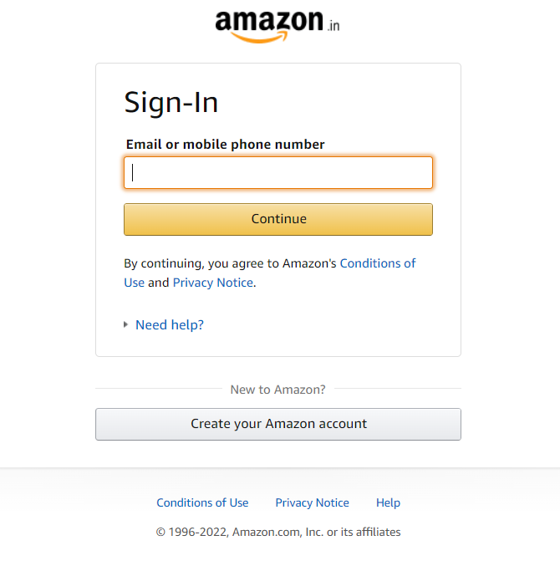

* Sing-In with email or phone number.
* Sing-Up with create Amazon account.

**Home Page:**

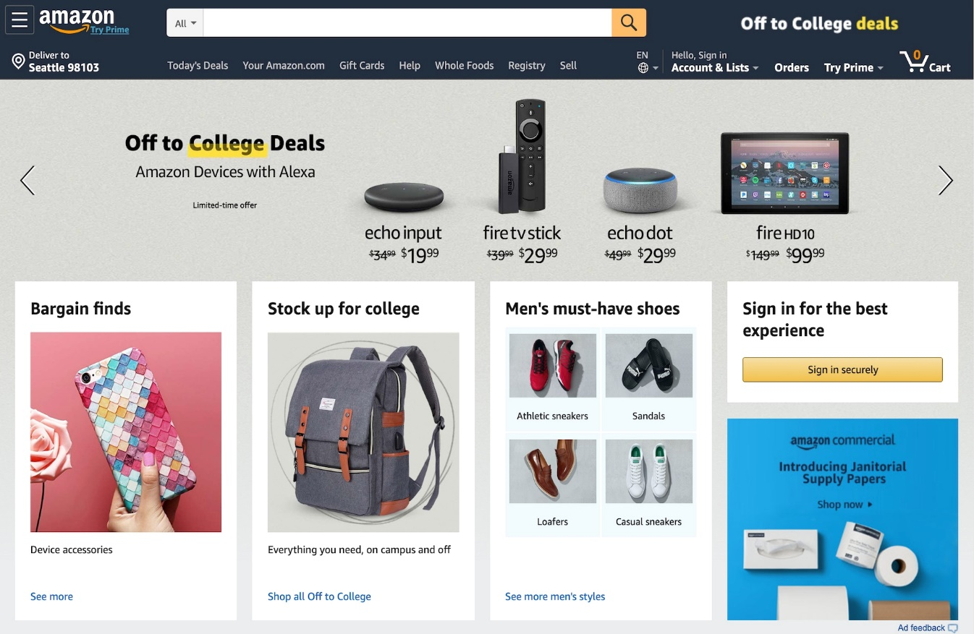

* Logo
* Current Delivery Location
* Search Bar
* Categories Details
* Icons (Orders, Add to cart, Login info, Social media links)
* Orders
* Add to cart
* Login info
* Social media links
* Slider with arrows (Images of all categories)
* Deals and Offers (Images of all categories)
* Trending (Images of all categories)
* Footer
* About the company
* Contact Details
* 24*7 Helplines
* Links to mobile apps (android and apple)

**Product Details:**

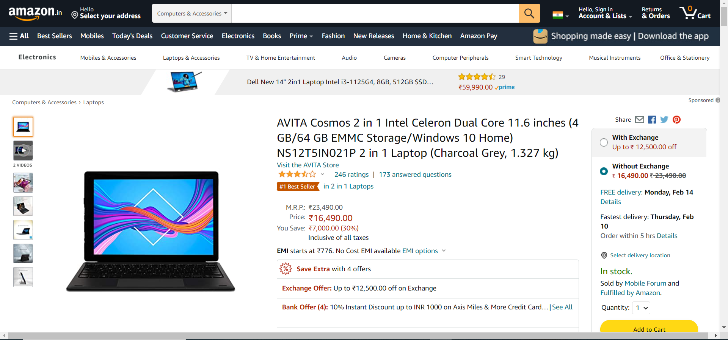

* Detailed description of selected product
* Multiple images
* Price and Payment Details
* Add to cart
* Buy now

**Buying Option:**

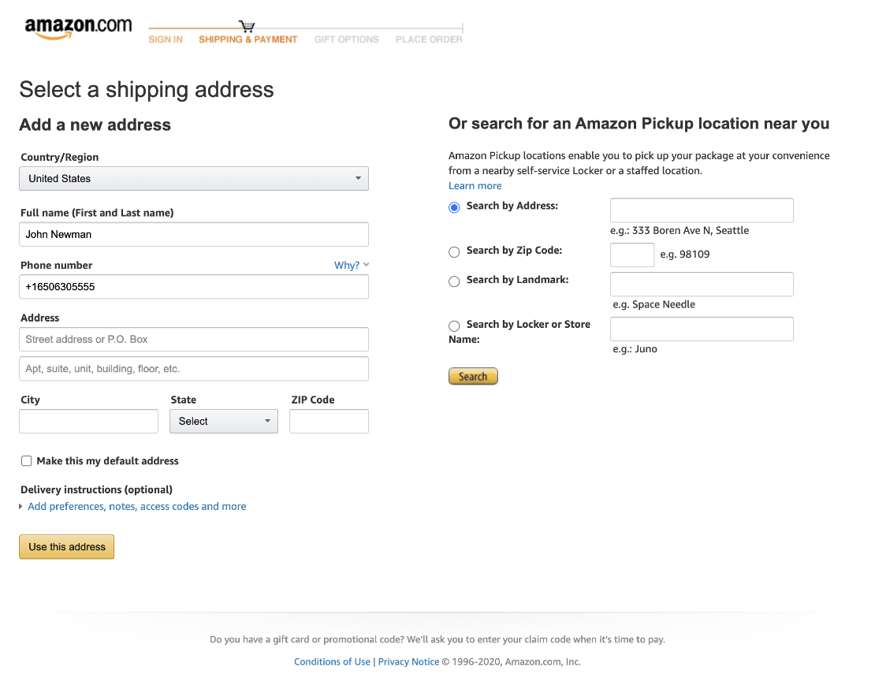

* Add a New address
* Select a delivery address (If already added)
* Edit address (If already added)
* Add delivery instruction

**Payment Gateway:**

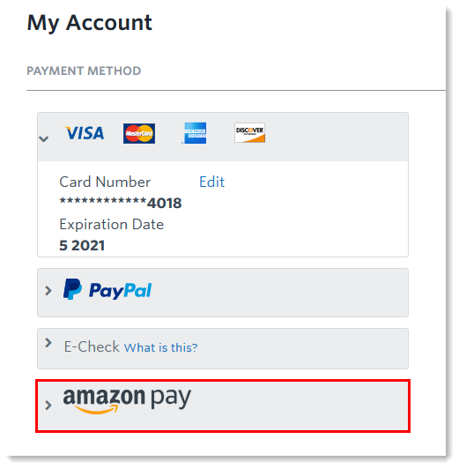

* Pay using cards
* Pay using UPI (Phone-pe, Google pay, Paytm)
* Pay using Amazon pay

